7. Methods

7.5 Pade Approximants

Question 1:

$f_{1}\left(x\right)={\left(1+x\right)}^{\frac{1}{2}}$

$$f_{1}\left(0\right)=1$$

${f^{'}}_{1}\left(0\right)=\frac{1}{2}{\left(1+\left(0\right)\right)}^{-\frac{1}{2}}=\frac{1}{2}$

${f''}_{1}\left(0\right)=-\frac{1}{4}{\left(1+\left(0\right)\right)}^{-\frac{3}{2}}=-\frac{1}{4}$

$$f_{1}^{\left(n\right)}\left(0\right)={\left(-1\right)}^{\left(k\right)}2^{-k}\prod_{n=0}^{k-1}{\left(2n-1\right)} for k≥1$$

Therefore, $$c_{k}=\frac{1}{k!}{\left(-2^{-1}\right)}^{\left(k\right)}\prod_{n=0}^{k-1}{\left(2n-1\right)} for k≥1$$

and $c_{0}=1$.

1. Radius of convergence: 1 such that we will require |x| <1 when we use the power series to estimate $f_{1}\left(x\right)$

$$\sqrt{2}=1.414213562$$

|  |  |  |
| --- | --- | --- |
| $$N$$ | $\sum_{k=0}^{N}{c_{k}}$ | Error |
| 5 | 1.42578125 | -0.011567687 |
| 10 | 1.409931182861328 | 0.0042823795 |
| 20 | 1.412667185988539 | 0.0015463763 |
| 50 | 1.413817654785574 | 0.0003959075 |
| 100 | 1.414073047717716 | 0.0001405146 |
| 150 | 1.414136978762613 | 0.0000765836 |

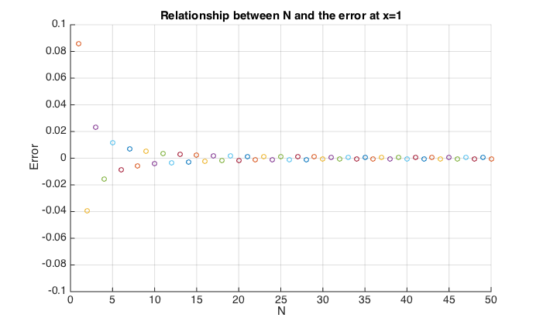

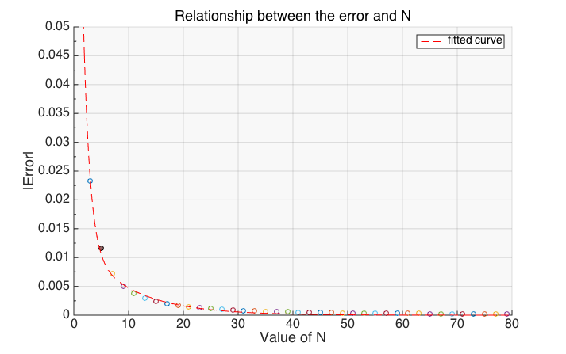

The magnitude of the error has an exponential decrease as the value of N increase linearly. From the graph on the right, we can see the error shows oscillation when N is small and tends to 0 when N grows.

Question 2:

|  |  |  |
| --- | --- | --- |
| $$L$$ | $Pade Approximant R_{L,L}$ | Error |
| 3 | 1.414201183431953 | 1.237894114258786e-05 |
| 5 | 1.414213551646055 | 1.072704036708672e-08 |
| 8 | 1.414213562372821 | 2.740030424774886e-13 |
| 10 | 1.414213562373095 | 4.440892098500626e-16 |

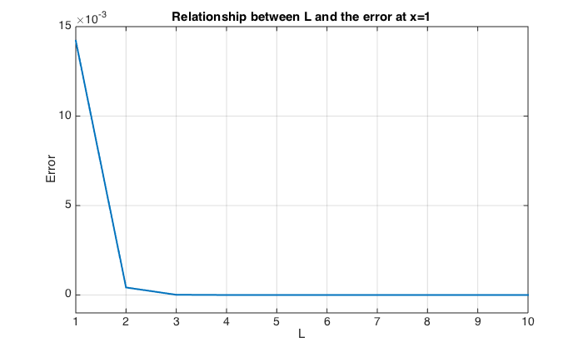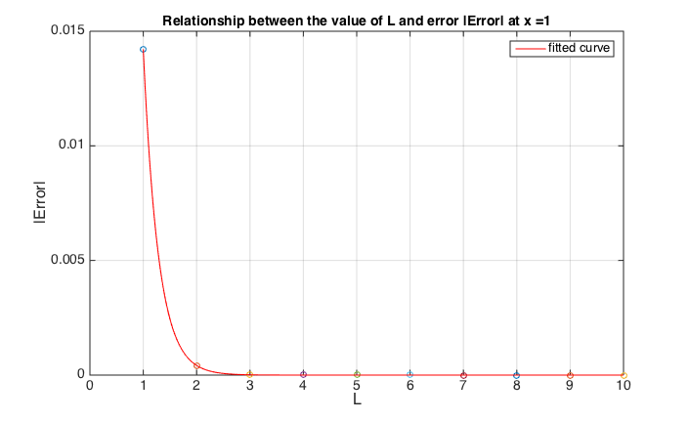

From the results, we can see the error reduce significantly as L increases. By plotting a curve of best fit, we can see there is an exponential decreases as L increases.

What is the smallest value to which the error can be reduced?  
 What determines this smallest value?

Does iterative improvement to the solution of (4) make any difference?

After running the iterative improvement, it improves the error from around 10^-5 to 10^-7 after 5 iterations. It makes a small difference in regards to the approximant we get.

Compare the results for the power series and for the Pad ́e approximant. Which method would you recommend to give an estimate for √2 to specified accuracy?

Comparing the chart from Q1 and Q2, we can clearly see that pade approximation converges to the actual value quicker than power series approximation by far. From the sample I generated, the error of pade approximation is at least less than 10^-5 while for power series, we will need up to and include the 150 terms for an approximation having an error less than 10^-5. Therefore, regarding to get the most accurate approximation, I will suggest the use of pade approximation.

In the extend on estimate root 2 to a specified accuracy, I may suggest the use of power series. We can easily visualize the number of terms we need in power series approximation for an approximation with given accuracy. However, it is more difficult to control which value of L to take for the pade approximation for a specific accuracy. Therefore, in the context of estimation of root 2 to a given accuracy, I may suggest the use of power series.

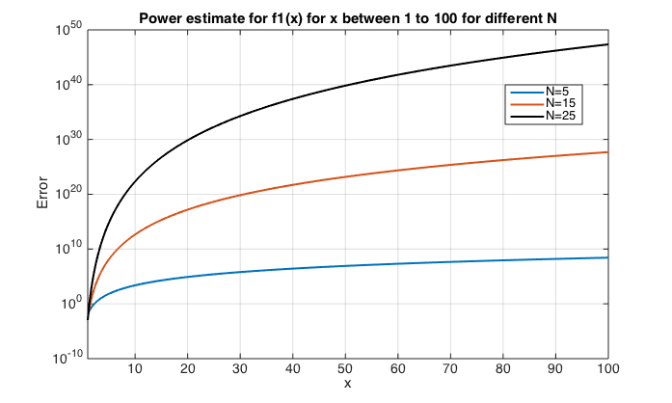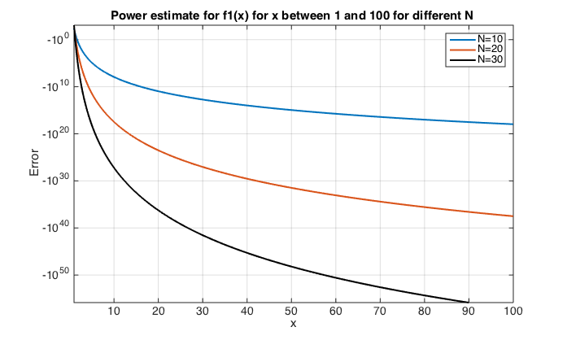Question 3:

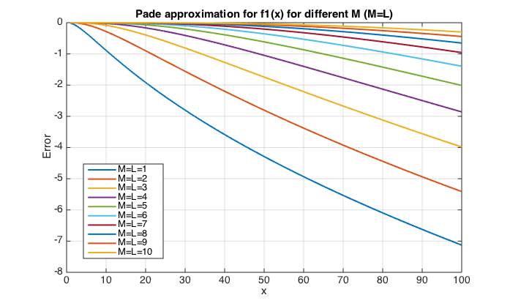

From the graph, we can see the magnitude of the error in power series approximation is way larger than the error in pade approximation overall from x=1 to 100.

The difference in error from two approximation diverges in an exponential manner as x increases. The range of error for pade approximation is around 0 to -8 while the range of the error’s magnitude varies from 0 to 10^47 as x increases.

We can spot there is a different behaviour on the magnitude of the error as we increase the terms being considered in both approximation. In pade approximation, the larger L we choose, the smaller error that we suffered from x=1 to 100; whereas in power series, the larger N we take, the larger error we obtain from the approximation as x increase.

This could be explained by the fact that the rate of the error reduces/increases is affected by the distance from the approximation point to the closest pole/branch point. As the branch point being at -1 for f1(x), the further we evaluate f1(x), the greater rate of error increases we suffer from the power series approximation. The more term we accept (the higher order of x we consider), the greater divergence we get as x increases. And with no surprise, we get an exponential increase in the error for power series. %%%%%

On the other hand, from the graph, we can see the power series approximation with N being odd tends to overestimation while N being even leads to underestimation. This could be because the coefficient of the power series we used to approximate has a factor of (-1)^n and given that the series diverges, the leading term of the polynomial dominates the series which caused oscillate around the actual result as N changes.

++++

In conclusion, pade approximation gives a better approximation than power series although both approximation shows some extends of divergence from the actual result from the graph as x increases.

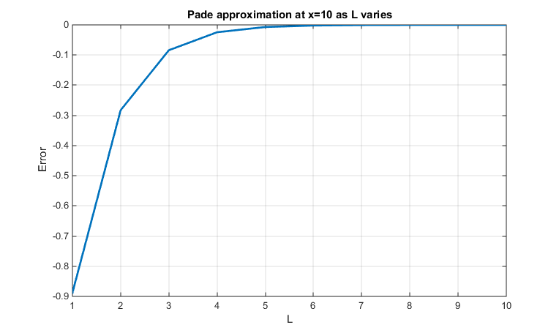

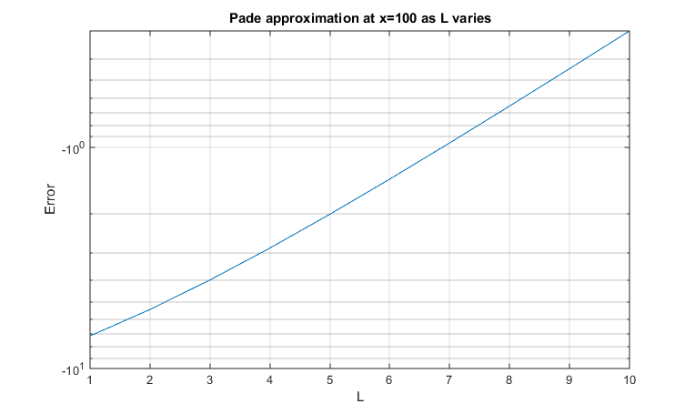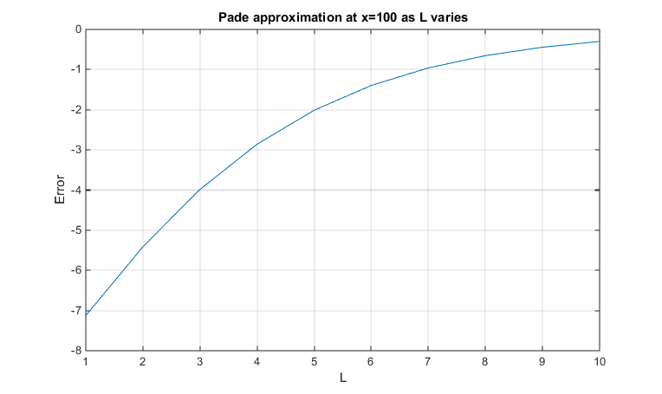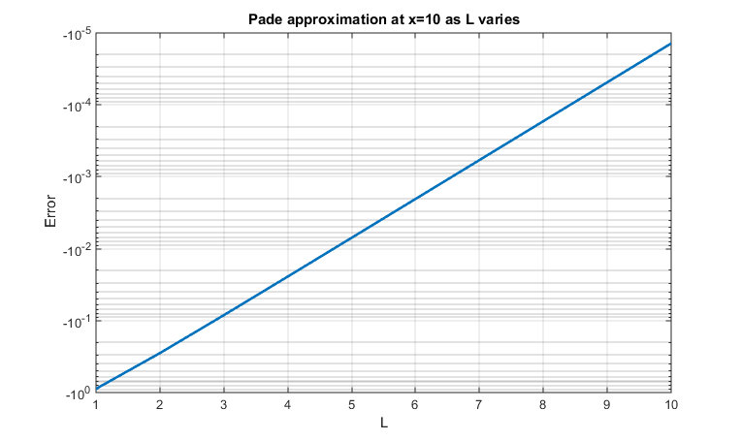

Similar to part 1, we can see the magnitude of the error decreases exponentially as L increases. The reason behind the rate of the error decrease being exponential can be explained by the ++++

Question 4:

|  |  |  |  |  |  |  |  |
| --- | --- | --- | --- | --- | --- | --- | --- |
| X | Actual Value | Pade Approximation | | | Power Series Approximation | | |
| $$f_{2}\left(x\right)$$ | $$f_{2}\left(x\right)$$ | Error | (%) | $$f_{2}\left(x\right)$$ | Error | (%) |
| 0.1 | 0.9156334 | 0.915633 | -6.06019E-08 | -6.61858E-06 | 0.91484044 | -0.00079 | -0.0866 |
| 0.2 | 0.85211088 | 0.852111 | 1.79275E-09 | 2.1039E-07 | -31.42068165 | -32.2728 | -3787.39 |
| 0.3 | 0.80118628 | 0.801186 | 1.3659E-08 | 1.70484E-06 | -15385.95186 | -15386.8 | -1920496 |
| 0.4 | 0.75881459 | 0.758815 | 1.32262E-07 | 1.74301E-05 | -1205207.548 | -1205208 | -1.6E+08 |
| 0.5 | 0.72265723 | 0.722658 | 6.24763E-07 | 8.64536E-05 | -35245832.94 | -3.5E+07 | -4.9E+09 |
| 0.6 | 0.69122594 | 0.691228 | 1.98126E-06 | 0.000286629 | -553748521.2 | -5.5E+08 | -8E+10 |
| 0.7 | 0.66351027 | 0.663515 | 4.91558E-06 | 0.000740844 | -5.67E+09 | -5.7E+09 | -8.5E+11 |
| 0.8 | 0.6387911 | 0.638801 | 1.02389E-05 | 0.001602852 | -4.25E+10 | -4.2E+10 | -6.7E+12 |
| 0.9 | 0.61653779 | 0.616557 | 1.88182E-05 | 0.003052243 | -2.51E+11 | -2.5E+11 | -4.1E+13 |
| 1 | 0.59634736 | 0.596379 | 3.15238E-05 | 0.005286148 | -1.23E+12 | -1.2E+12 | -2.1E+14 |
| 2 | 0.46145532 | 0.46196 | 0.000505175 | 0.109474403 | -4.15E+16 | -4.1E+16 | -9E+18 |
| 3 | 0.38560201 | 0.387274 | 0.001671949 | 0.433594569 | -1.84E+19 | -1.8E+19 | -4.8E+21 |
| 4 | 0.33522136 | 0.338565 | 0.003343908 | 0.997522332 | -1.38E+21 | -1.4E+21 | -4.1E+23 |
| 5 | 0.29866975 | 0.303969 | 0.005299605 | 1.774402977 | -3.94E+22 | -3.9E+22 | -1.3E+25 |
| 6 | 0.27063301 | 0.278017 | 0.007384201 | 2.728492272 | -6.08E+23 | -6.1E+23 | -2.2E+26 |
| 7 | 0.24828135 | 0.257783 | 0.009501752 | 3.827009971 | -6.15E+24 | -6.1E+24 | -2.5E+27 |
| 8 | 0.22994778 | 0.241543 | 0.01159563 | 5.042723063 | -4.56E+25 | -4.6E+25 | -2E+28 |
| 9 | 0.2145771 | 0.228211 | 0.013633636 | 6.353723642 | -2.67E+26 | -2.7E+26 | -1.2E+29 |
| 10 | 0.20146425 | 0.217063 | 0.015598475 | 7.7425525 | -1.30E+27 | -1.3E+27 | -6.4E+29 |
| 11 | 0.19011779 | 0.2076 | 0.017481876 | 9.195286529 | -5.43E+27 | -5.4E+27 | -2.9E+30 |
| 12 | 0.18018332 | 0.199464 | 0.019281009 | 10.70077346 | -2.00E+28 | -2E+28 | -1.1E+31 |
| 13 | 0.171398 | 0.192394 | 0.020996304 | 12.25002849 | -6.66E+28 | -6.7E+28 | -3.9E+31 |
| 14 | 0.16356229 | 0.186192 | 0.022630063 | 13.83574571 | -2.02E+29 | -2E+29 | -1.2E+32 |
| 15 | 0.15652164 | 0.180707 | 0.02418564 | 15.45194661 | -5.70E+29 | -5.7E+29 | -3.6E+32 |
| 16 | 0.15015426 | 0.175821 | 0.025666934 | 17.09371014 | -1.50E+30 | -1.5E+30 | -1E+33 |
| 17 | 0.14436271 | 0.171441 | 0.027078074 | 18.75697256 | -3.73E+30 | -3.7E+30 | -2.6E+33 |
| 18 | 0.13906806 | 0.167491 | 0.028423156 | 20.43830595 | -8.79E+30 | -8.8E+30 | -6.3E+33 |
| 19 | 0.13420555 | 0.163912 | 0.029706212 | 22.1348607 | -1.98E+31 | -2E+31 | -1.5E+34 |
| 20 | 0.12972152 | 0.160653 | 0.030931099 | 23.84423137 | -4.27E+31 | -4.3E+31 | -3.3E+34 |

Remark: Relative Error (%)=(Errror/Actual Value)*100%

Compare balblabla

Question 5